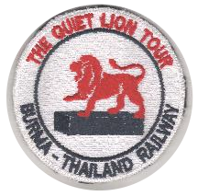

BURMA THAILAND RAILWAY MEMORIAL ASSOCIATION (Inc)
Email: info@btrma.org.au
Website: www.btrma.org.au

MEMBERSHIP FORM
Memberships are renewed at the end of financial year.
Our membership period is 1 July to 30 June in any given year.

If you would like to become a member, renew your membership (memberships last 1 year) or would like to make a donation, please fill out this form and forward to the Association by email or post.

Mr Mrs Ms Miss Other, please specify:

First name:

Surname:

Address:

Suburb: State: Postcode:

Email:

Telephone.: Mobile: Fax:

Annual membership: $5.00

Donation: $

Total: $

Payment via Direct deposit:
Bank: Australian Defence Credit Union
Account name: BTRMA
BSB: 642 170
Account number: 1000 57683
Reference: (please insert your name)
Please arrange a direct deposit and forward your completed form and receipt to: info@btrma.org.au

Payment via Cheque:
Cheques payable to: Burma Thailand Railway Memorial Association
Please enclose it along with this completed form and post to: P O Box 853, Canning Bridge, Applecross WA 6153

